How to Use Data to Support Quality Management

Why This Matters
As a provider, you may feel confident that you offer high-quality services, but how do you know?
Quality management helps you see whether your services are working like they should be, catch problems early, prevent repeat issues, and show surveyors that quality is actively monitored and managed. Quality management is not about paperwork or complex data. It is about paying attention, learning from what happens, and making changes when needed.

What Statute Requires
Minnesota statute requires all assisted living (144G.42 Subd. 2) and home care (144A.479 Subd. 3) providers engage in quality management. This means monitoring the quality of services provided; reviewing problems, incidents, and complaints; and using that information to make improvements. Quality management activities should be practical, proportional to the size of the organization, and focused on dignity, safety, and quality.
What does “proportional” mean?
Proportional means doing what makes sense for your organization.
Examples:
- A small provider may track a few key issues and review them during routine staff or leadership meetings.
- A larger provider may track more items, use spreadsheets or reports, and review data more formally.
The Minnesota Department of Health does not require a certain number of quality measures. Surveyors expect that your activities match your size, services, and risks.

Quality Data Measures
Examples of quality data may include:
- Number of falls during a specific period
- Medication errors
- Themes from complaints or grievances
- Survey results
- Staff turnover rates
Quality data includes information you routinely collect and additional information you may need to gather to monitor resident care and safety over time. It should be intentional, consistent, and focused on key risk areas, such as falls, medication errors, infections, and maltreatment concerns.
You do not need complex systems to begin using data effectively. However, providers are expected to identify priority areas, collect reliable data, identify gaps and collect additional data when needed, and review information over time to detect patterns, address concerns, and improve outcomes. In some cases, this may require strengthening documentation practices or adding new data tracking processes.

What Should I Track?
A useful starting point to ask:
- What is the problem?
- What are we trying to improve or prevent?
If an issue affects safety, quality of life, dignity, service delivery, or compliance, it is likely appropriate to track. This not only includes areas of concern, but also practices that are working well and could be reinforced or expanded.
Common sources for identifying quality issues include:
- Recent survey findings or corrective action plans.
- Complaints or grievances.
- Incident reports (e.g., falls, medication errors).
- Satisfaction survey results from individuals served and their families.
- Concerns raised by individuals served or family councils (when present).
- Staffing challenges or turnover.
- High‑risk areas identified by leadership.
- Practices or outcomes that are consistently working well (e.g., strong satisfaction of individuals served, effective workflows, high-performing teams).

Align Data with Strategic Priorities.
Quality data should reflect both regulatory requirements and organizational priorities. Common priorities include safety, quality of life, dignity, client or resident satisfaction, and workforce stability. Connecting quality data to these priorities shows information is being used intentionally and supports meaningful improvement.
While organizations part of a larger system may participate in company-wide quality initiatives, each location should also identify and monitor measures that reflect its unique services, population, risks, and opportunities for improvement. Organizations can benefit from collaborating and sharing successful practices across locations while maintaining quality activities that are meaningful and responsive to their specific setting.

How to Set Up a Quality Measure
A quality measure is a clear and consistent way to track something over time to understand how well services are working, where improvements may be needed, and what is important to those receiving and delivering care.
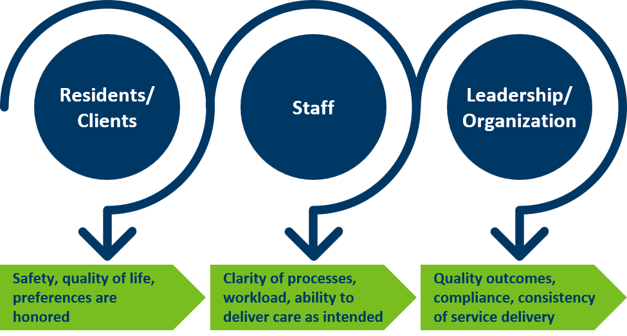
Each measure should reflect what matters most to the individuals receiving services and those who support and provide their care.

Each quality measure should be clearly defined. Use the following sections to build one measure at a time.

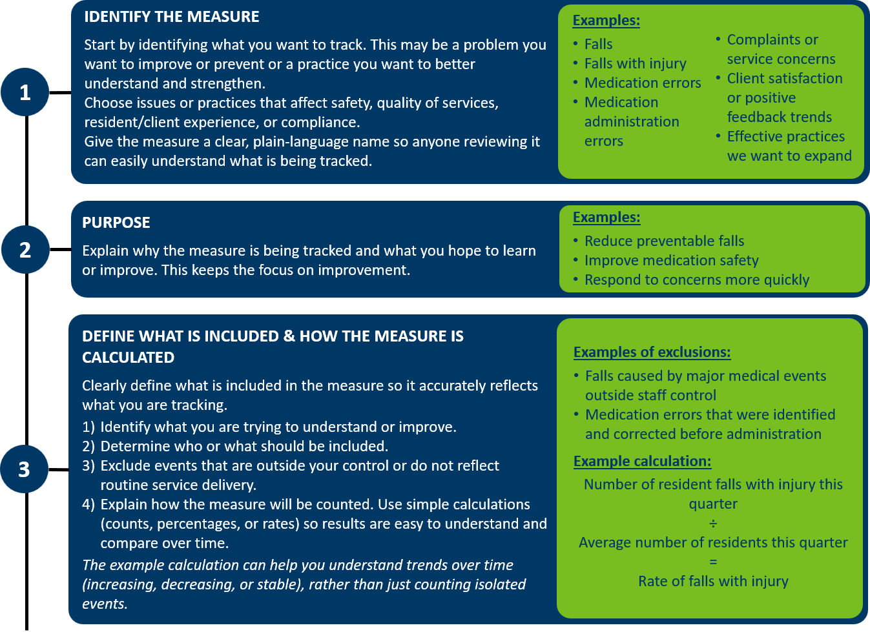

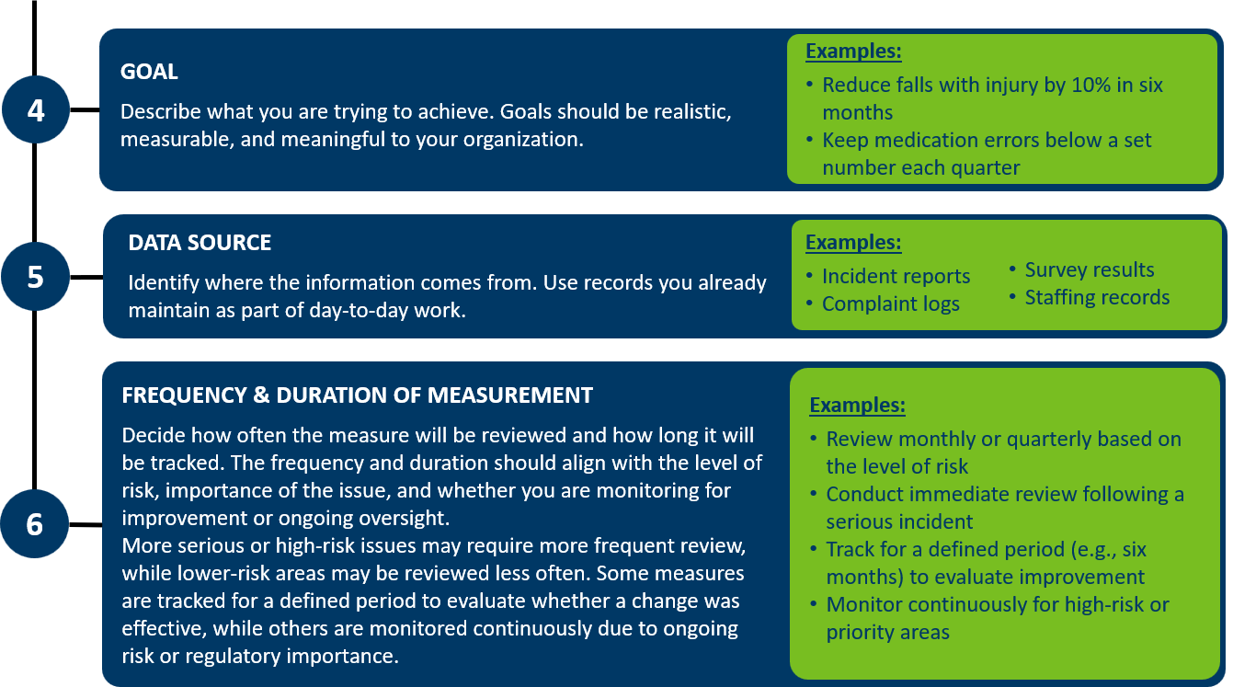

Using Data to Support Quality Management and Make Decisions
Quality management focuses on using the information you collect, not just measuring it.
Important: Measurement is not an intervention.
Tracking data or auditing practice alone will not create change.
If you want different results, you must take action and do something differently.

You do not need to track many measures. A small number of meaningful measures, reviewed regularly and acted on, is most effective.
Quality data is typically reviewed by leadership, managers, or a designated quality team, depending on the size of the organization. Reviews should occur at a frequency that reflects the level of risk (e.g., monthly, quarterly, after significant events). The process for reviewing quality data, including roles, responsibilities, and frequency, should be clearly described in an organization’s quality management plan.
All decisions and any follow-up to evaluate whether changes were effective should be documented. If changes do not result in immediate improvement, that is okay. Organizations should review what they are learning from the data, reassess contributing factors, and adjust their approach as needed to achieve better outcomes.

Using Multiple Sources of Information Together
Quality issues rarely exist on their own. Reviewing different sources of information together can explain why something is happening.
For example, an increase in complaints may occur at the same time as staff turnover, or falls may increase during periods of new admissions. Looking at information together helps you better understand the situation and identify appropriate actions.

Sources of Information
You can use a combination of informational sources to monitor quality and guide improvement, including incident data, complaints or feedback, workforce information, survey findings, and reference measures or benchmarks. Using multiple sources over time helps confirm whether actions taken are effective and whether improvements are sustained.
Examples: Common Quality Data Sources by Category
The following list is only meant to serve as examples. Providers are expected to select data sources based on their services, risks, and population needs. Not all providers will track every item, but all providers should monitor key risk, experience, workforce, and compliance indicators.

Area | Examples
High-Risk Quality Indicators | - Service plan compliance  - Falls (especially falls with injury)  - Medication errors  - Infection control issues  - Timeliness of visits (home care)  - Client/resident complaints  - Staff training and competency
Feedback and Experience Data | - Complaint and grievance logs and/or positive feedback  - Resident or client satisfaction surveys  - Family satisfaction surveys (particularly in assisted living)  - Input from resident or family councils (when present, if applicable)  - Feedback related to communication, scheduling, or service quality
Workforce Indicators | - Staff satisfaction surveys  - Staff turnover and retention data  - Staff training and competency records and ongoing evaluations
Survey and Compliance Data | - State survey findings  - Corrective actions and follow-up monitoring  - Review of past citations for sustained compliance
State and National Benchmarks | - Minnesota Assisted Living Report Card  - Centers for Medicare & Medicaid Services (CMS) Care Compare for Medicare-Certified Home Care

Using Quality Data to Drive Improvement
Collecting and tracking quality data is only the first step in quality management. Assisted living and home care providers are expected to review quality data and use it to decide whether changes are needed.
After reviewing quality data, consider whether you are meeting your goals. If not, assess why the issue is occurring and identify actions to address it. During data review ask:
- Are we meeting the goal?
- Are we seeing patterns or changes over time?
- What is contributing to these results (both challenges and successes)?
- What do we need to do differently based on what we are learning?

Actions taken may include:
- Updating policies or procedures.
- Providing staff training.
- Adjusting staffing or supervision.
- Improving communication.
- Incorporating feedback from individuals serviced, families and councils (when present).
- Completing an improvement project.
- Spreading practices that are working well.

Documentation
Quality management activities must be documented to show how data is reviewed and used to guide improvement. Documentation should include:
- What data was reviewed.
- Key findings.
- Decisions made.
- Actions taken.
- Follow‑up to determine whether changes were effective.
Quality management documentation must be maintained for at least two years and is the primary evidence surveyors use to evaluate compliance.
Surveyors typically expect to see documentation showing:
- Quality measures being tracked.
- Evidence of ongoing monitoring.
- Review summaries that document discussion and decisions.
- Record of actions taken when goals are not met.
- Follow-up monitoring to confirm whether changes were effective.

Survey Readiness
As a best practice, store all quality management documentation in one central, clearly labeled location, either electronic or paper. Surveyors should be able to locate quality documentation easily, without searching across multiple systems or files.
Documentation must be organized, accessible, and available at the time of survey or investigations.

Quality Management Tools
These tools are designed to work together as a simple and practical quality management documentation system. Each tool has a clear purpose on its own. When used together, they create organized, survey‑ready documentation showing how quality data is monitored, reviewed, and used for improvement.

Data Source Inventory
The data source inventory helps identify and organize the quality data you already collect, such as incident reports, complaints, surveys, staffing information, and survey findings. The inventory is used as a reference and only needs to be updated when data sources change.
Quality Measure Development Worksheet
This worksheet documents what quality measures you are tracking and why. It explains how the measure was selected, how it is defined, and how it will be reviewed. Complete this worksheet when starting a new measure, updating an existing one, or explaining to surveyors how and why a measure was chosen.
Quality Measure Tracking Tool
The quality measure tracking tool records results for each quality measure at each review period. One tracking tool is used per measure and is updated consistently over time. This tool helps identify trends or changes in performance.
Quality Review and Action Summary
The quality review and action summary documents what information was reviewed, what was identified, what decisions were made, and what follow-up actions are planned. This summary is completed during scheduled reviews, quality meetings, or after significant incidents. One summary is completed for each review.

This material was prepared by Stratis Health under contract with the Minnesota Department of Health (MDH). Use of this tool is not mandated by MDH, nor does its completion ensure regulatory compliance.

